A Machine Learning Model for Average Fuel Consumption in Heavy Vehicles

In this paper author is describing concept to predict average fuel consumption in heavy vehicles using Machine Learning Algorithm such as ANN (Artificial Neural Networks). To predict fuel consumption author has extracted 7 predictor features from heavy vehicle dataset such as

**num_stops, time_stopped, average_moving_speed, characteristic_acceleration, aerodynamic_speed_squared, change_ in_kinetic_energy, change_in_potential_energy, class**

Above seven features are recorded from each vehicle travel up to 100 kilo meters like number of times vehicle stop, total stopped time taken etc. All this values are collected from heavy vehicle and use as dataset to train ANN model. Below are some value from above seven predictor features.

**num_stops, time_stopped, average_moving_speed, characteristic_acceleration, aerodynamic_speed_squared, change_ in_kinetic_energy, change_in_potential_energy, class**

7.0, 7.0, 93.0, 34, 8.4, 4, 25.6, 9

7.0, 7.0, 91.0, 34, 8.3, 4, 25.7, 9

8.9, 8.9, 151.0, 26, 10.9, 6, 15.1, 12

9.3, 9.3, 160.0, 25, 11.3, 6, 13.7, 13

8.4, 8.4, 158.0, 25, 11.2, 6, 13.8, 13

All bold names are the dataset column names and all double values are the dataset values for each vehicle. Last column will be consider as class name which represents fuel consumption for that vehicle. Entire dataset will be used to train ANN model and whenever we give new record then ANN algorithm will apply train model on that test record to predict it average fuel consumption.

Below are some test records

**num_stops, time_stopped, average_moving_speed, characteristic_acceleration, aerodynamic_speed_squared, change_ in_kinetic_energy, change_in_potential_energy**

7.0, 7.0, 93.0, 34, 8.4, 4, 25.6

7.0, 7.0, 91.0, 34, 8.3, 4, 25.7

8.9, 8.9, 151.0, 26, 10.9, 6, 15.1

9.3, 9.3, 160.0, 25, 11.3, 6, 13.7

8.4, 8.4, 158.0, 25, 11.2, 6, 13.8

In above test data class value as fuel consumption is not there and when we applied this test record on ANN model then ANN will predict fuel consumption class value for that test record. Entire train and test data available inside ‘dataset’ folder.

The ANN model is developed by using duty cycle’s dataset collected from a single truck, with an approximate mass of 8, 700kg exposed to a variety of transients including both urban and highway traffic in the Indianapolis area. Data was collected using the SAE J1939 standard for serial control and communications in heavy duty vehicle networks.

Abstract

In this paper we used vehicle travel distance rather than the traditional time period when developing individualized machine learning models for fuel consumption. This approach is used in conjunction with seven predictors derived from vehicle speed and road grade to produce a highly predictive neural network model for average fuel consumption in heavy vehicles. The proposed model can easily be developed and deployed for each individual vehicle in a fleet in order to optimize fuel consumption over the entire fleet. The predictors of the model are aggregated over fixed window sizes of distance travelled. Different window sizes are evaluated and the results show that a 1 km window is able to predict fuel consumption with a 0.91 coefficient of determination and mean absolute peak-to-peak percent error less than 4% for routes that include both city and highway duty cycle segments.

ANN Working Procedure

To demonstrate the way to build associate ANN neural network primarily based image classifier, we tend to shall build a vi layer neural network that may establish and separate one image from alternative. This network that we tend to shall build may be a terribly little network that we are able to run on a CPU additionally. ancient neural networks that square measure excellent at doing image classification have more parameters and take plenty of your time if trained on traditional CPU. However, our objective is to point out the way to build a real-world convolutional neural network exploitation TENSORFLOW. Neural Networks square measure primarily mathematical models to resolve associate improvement drawback. they're made from neurons, the fundamental computation unit of neural networks. A nerve cell takes associate input (say x), do some computation thereon (say: multiply it with a variable w and adds another variable b) to provide a worth (say; z= wx + b). This price is passed to a non-linear perform referred to as activation perform (f) to provide the ultimate output (activation) of a nerve cell. There square measure several varieties of activation functions. one in all the popular activation perform is Sigmoid. The nerve cell that uses sigmoid perform as associate activation perform are going to be referred to as sigmoid nerve cell. betting on the activation functions, neurons square measure named and there square measure several varieties of them like RELU, TanH. If you stack neurons in a very single line, it’s referred to as a layer; that is that the next building block of neural networks. See below image with layers To predict image category multiple layers operate one another to induce best match layer and this method continues until no additional improvement left. Modules info This project consists of following modules Upload serious Vehicles Fuel Dataset: exploitation this module we are able to transfer train dataset to application. Dataset contains comma separated values. Read Dataset & Generate Model: exploitation this module we are going to take apart comma separated dataset and so generate train and check model for ANN from that dataset values. Dataset are going to be divided into eightieth and two hundredth format, eightieth are going to be wont to train ANN model and two hundredth are going to be wont to check ANN model. Run ANN Algorithm: exploitation this model we are able to produce ANN object and so feed train and check information to create ANN model. Predict Average Fuel Consumption: exploitation this module can|we'll|we are going to} transfer new check information and so ANN will apply train model thereon check information to predict average fuel consumption for that check records. Fuel Consumption Graph: exploitation this module we are going to plot fuel consumption graph for every check record

Screen shots

To run this project double click on ‘run.bat’ file to get below screen

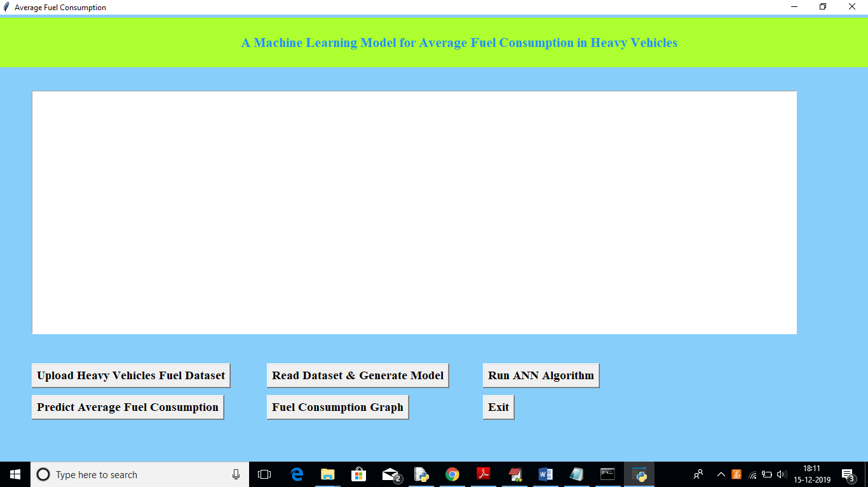

In above screen click on ‘Upload Heavy Vehicles Fuel Dataset’ button to upload train dataset

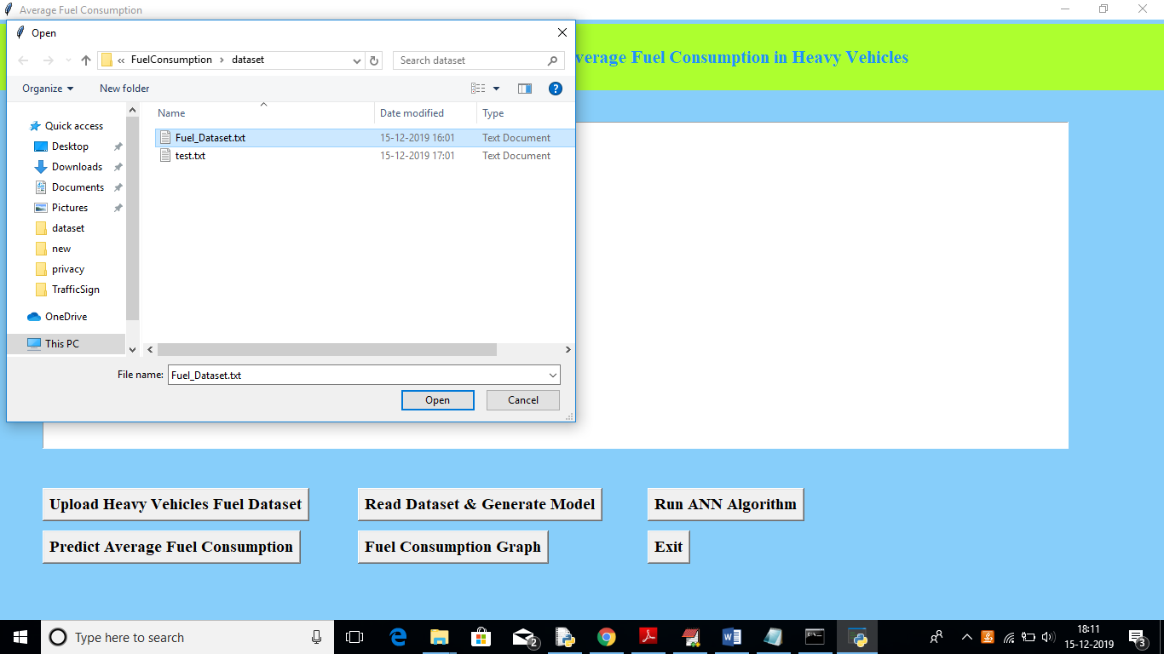

In above screen uploading ‘Fuel_Dataset.txt’ which can be used to train model. After uploading dataset will get below screen

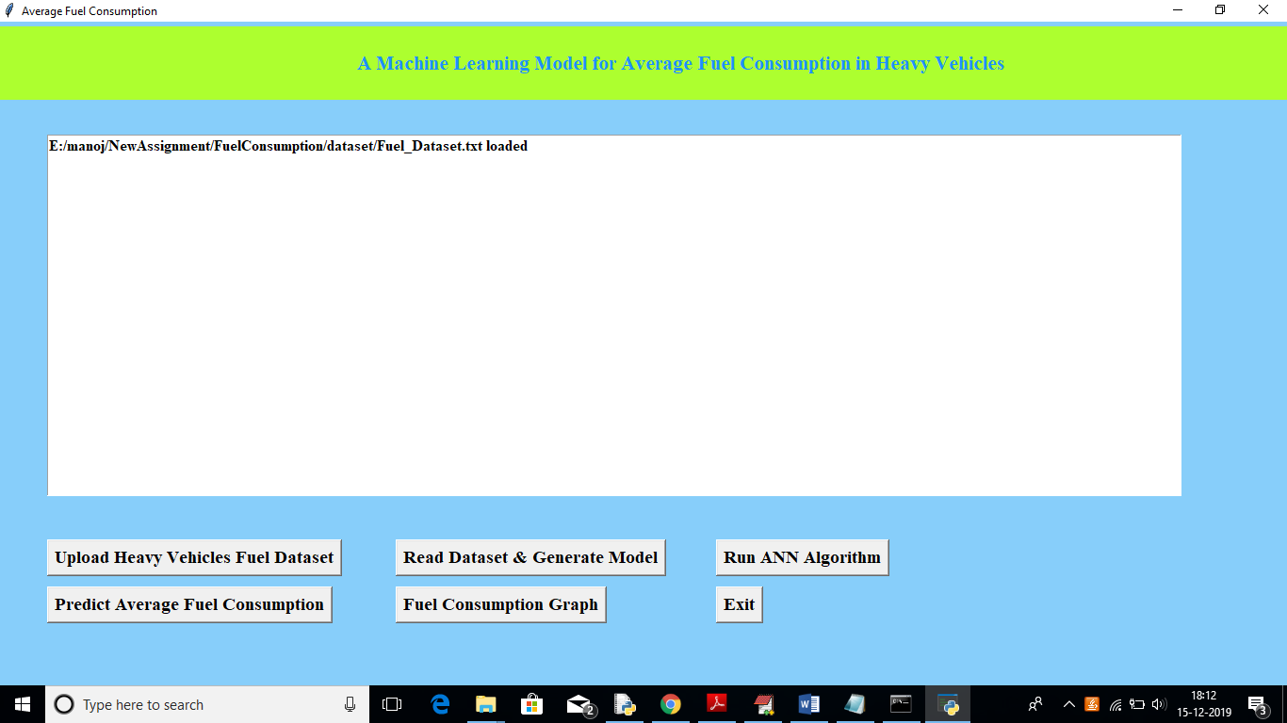

Now in above screen click on ‘Read Dataset & Generate Model’ button to read uploaded dataset and to generate train and test data

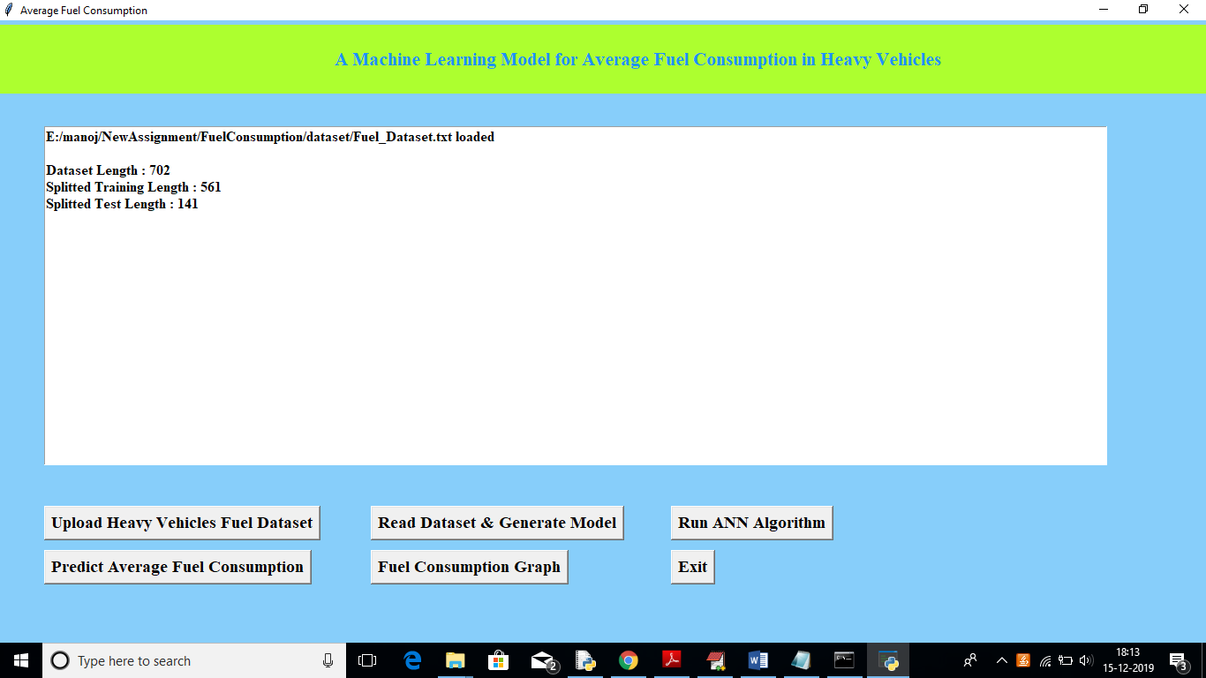

In above screen we can see total number of records in dataset, number of records used for training and number for records used for testing. Now click on ‘Run ANN Algorithm’ button to input train and test data to ANN to build ANN model.

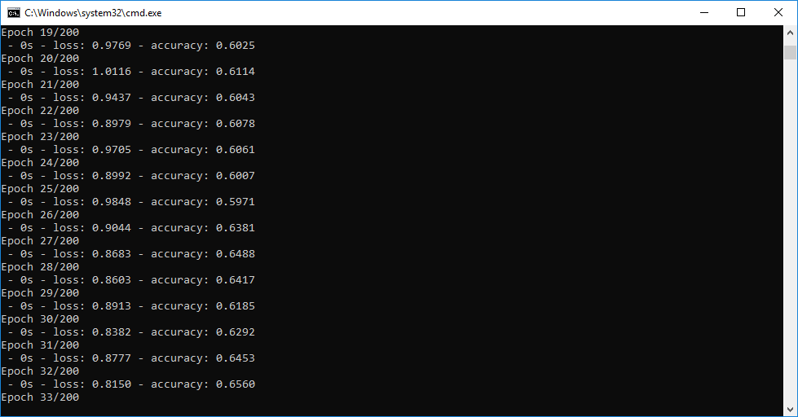

In above black console we can see all ANN processing details, After building model will get below screen

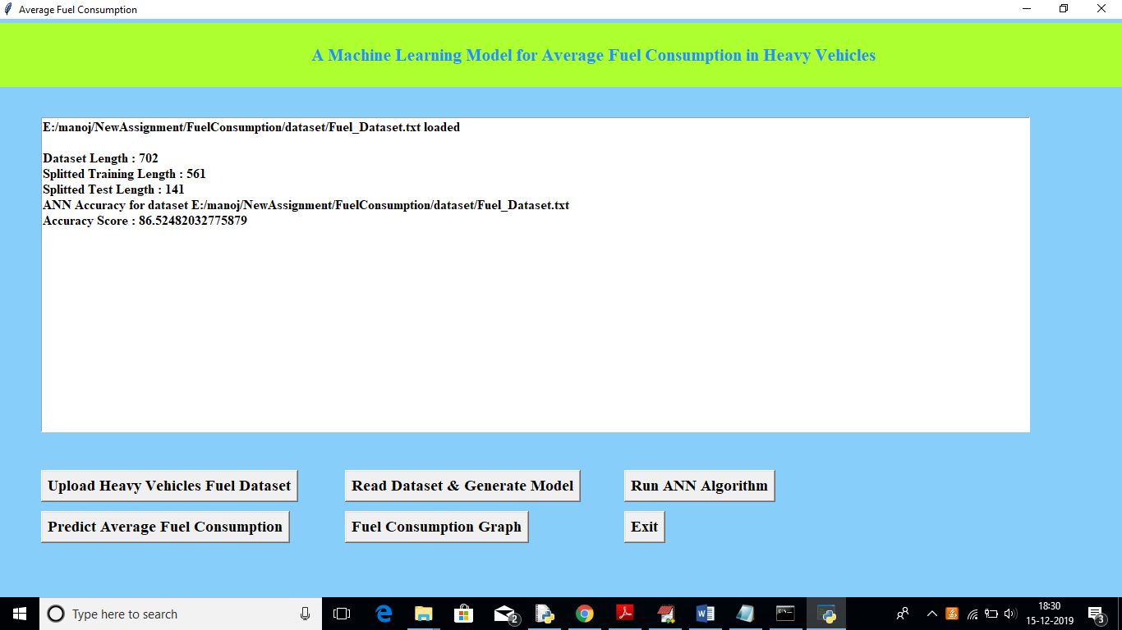

In above screen we got ANN prediction accuracy upto 86%. Now click on ‘Predict Average Fuel Consumption’ button to upload test data and to predict consumption for test data

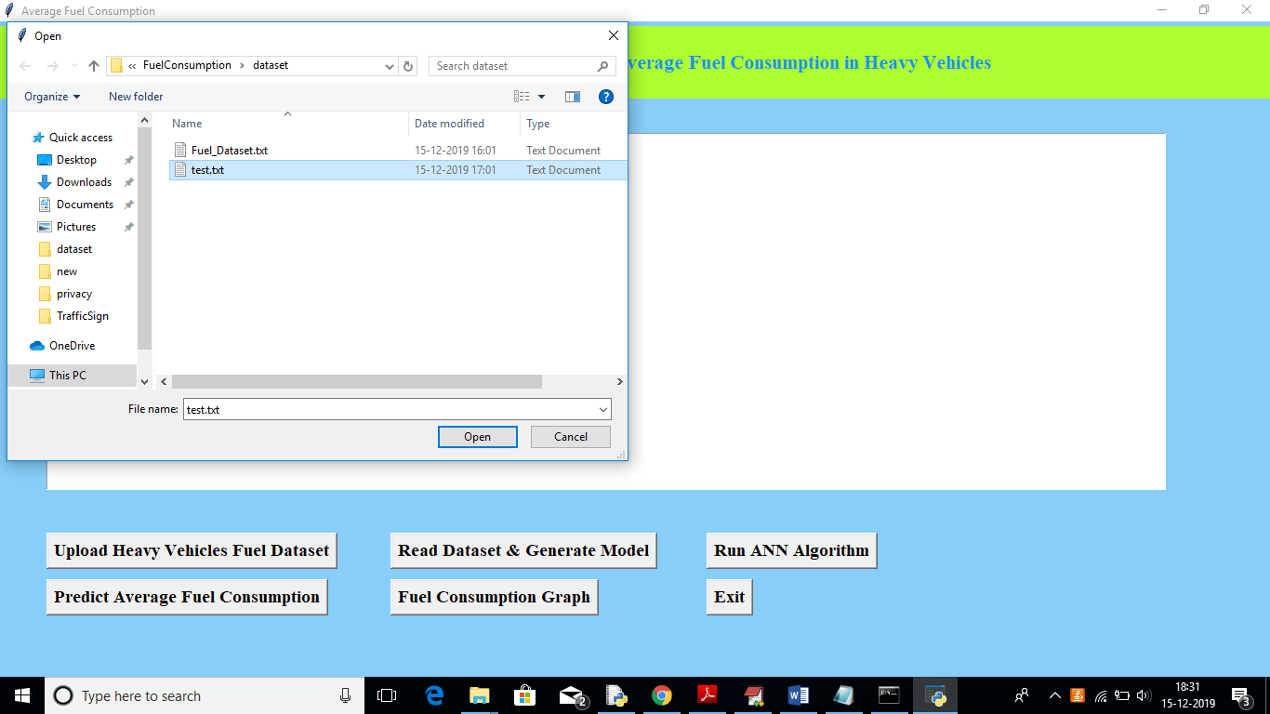

After uploading test data will get fuel consumption prediction result in below screen

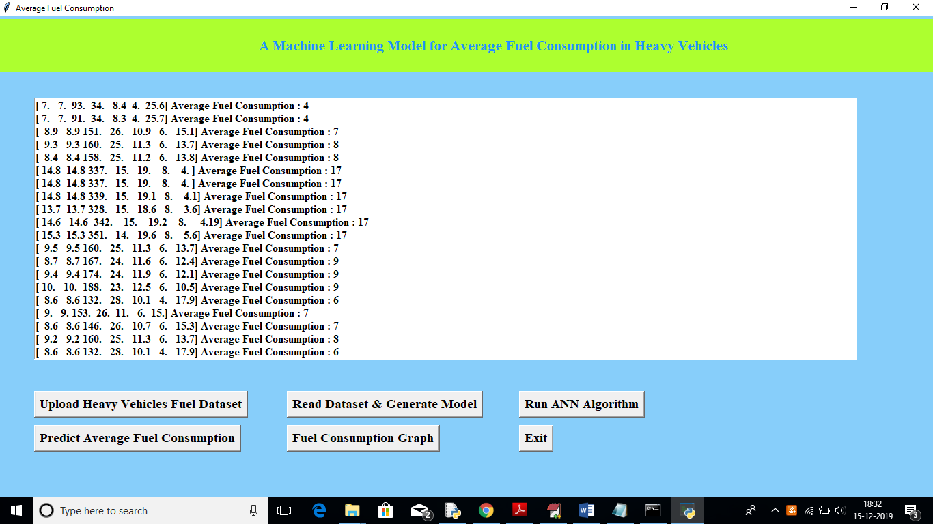

In above screen we got average fuel consumption for each test record per 100 kilo meter. Now click on ‘Fuel Consumption Graph’ to view below graph

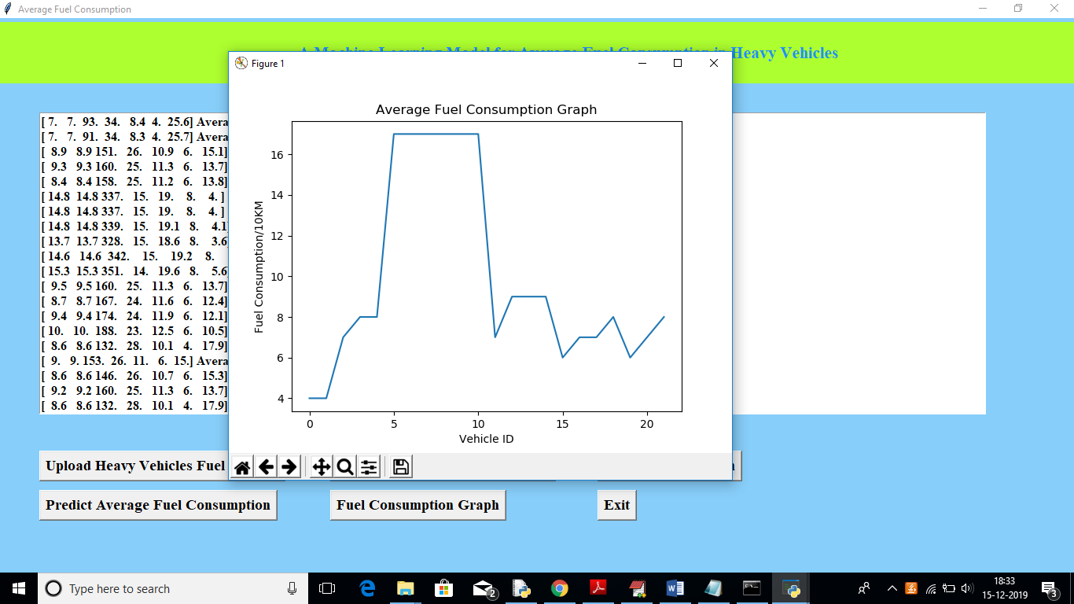

In above graph x-axis represents test record number as vehicle id and y-axis represents fuel consumption for that record.

Conclusion: Using this paper and ANN algorithm we are predicting fuel consumption for test data